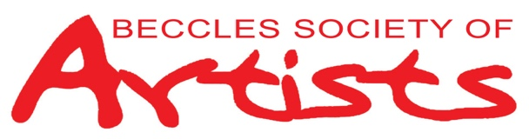

**MEMBERSHIP FORM JANUARY 1ST to DECEMBER 31ST 2026**

PLEASE PRINT DETAILS:

|  |  |
| --- | --- |
| Title and first name |  |
| Surname |  |
| Address |  |
| Telephone number |  |
| Email |  |

Membership subscription for 2026 is £32 and should be paid before or at the first meeting in January. Includes the right to enter work into the Annual Exhibition.

Payment type:

BACS Sort code: 30-95-24. Account No: 00887804. Beccles Society of Artists.

Ref: 2026 subs + your name. (bring form to meeting and hand to Anne Willis)

Date of payment ……………………………….

CHEQUE Payable to: Beccles Society of Artists.  
(bring form and cheque to meeting and hand to Anne Willis

CASH Bring form and cash to meeting and hand to Anne Willis

In line with UK law on data protection, we need your consent for Beccles Society of Artists to hold your personal data to enable us to contact you about news, events and activities related to the Society. We may also take photos from time to time to publicise activities and share on our website, local media and social media.

By signing below, you are confirming consent to the above. If you do not wish your photos to be shared in this way, please contact the Chairman. For further information on how your data might be used, our Privacy Policy can be found on our website or a copy can be requested from the Chairman.

Signed ………………………………………………………………. Date ………………………………………

You can withdraw or change your consent at any time by contacting beccles.bsa.artists@hotmail.com or writing to

BSA Chair James Davis, 2 Stobart Close, Beccles NR34 9LT.